SOLO STRATEGIST

Symbotic, Inc.
The Automation Backbone of Commerce

────────────────────────────────────────
A Dual-Horizon Research Report: Equity Analysis & Ticker Collision Risk

February 17th 2026 | NASDAQ: SYM

SNAPSHOT
Market Cap | ~$33B
Price (Feb 17, 2026) | ~$55
52-Week Range | $16.32 – $87.88
Q1 FY2026 Revenue | $630M (+29% YoY)
FY2025 Revenue | $2,247M (+26% YoY)
Adj. EBITDA (Q1) | $67M (10.6% margin)
Backlog | $22.3B
Cash & Equivalents | $1.8B
Fully Diluted Shares | ~601M (sourced from 10-K)
Analyst Consensus | Hold | Avg. PT ~$55

I. The Investment Thesis: The “SYM” Duality
This report applies our Framework for Value-Centric Strategic Allocation to Symbotic Inc. (NASDAQ: SYM), the AI-enabled robotics leader transforming warehouse logistics for the world’s largest retailers. Simultaneously, it examines the Symbiotic Protocol (symbiotic.fi), a Paradigm-backed universal staking layer on Ethereum, and the unusual “Ticker Collision” risk that binds the two otherwise unrelated entities.

Exhibit 1: The SYM Duality — Collision Map
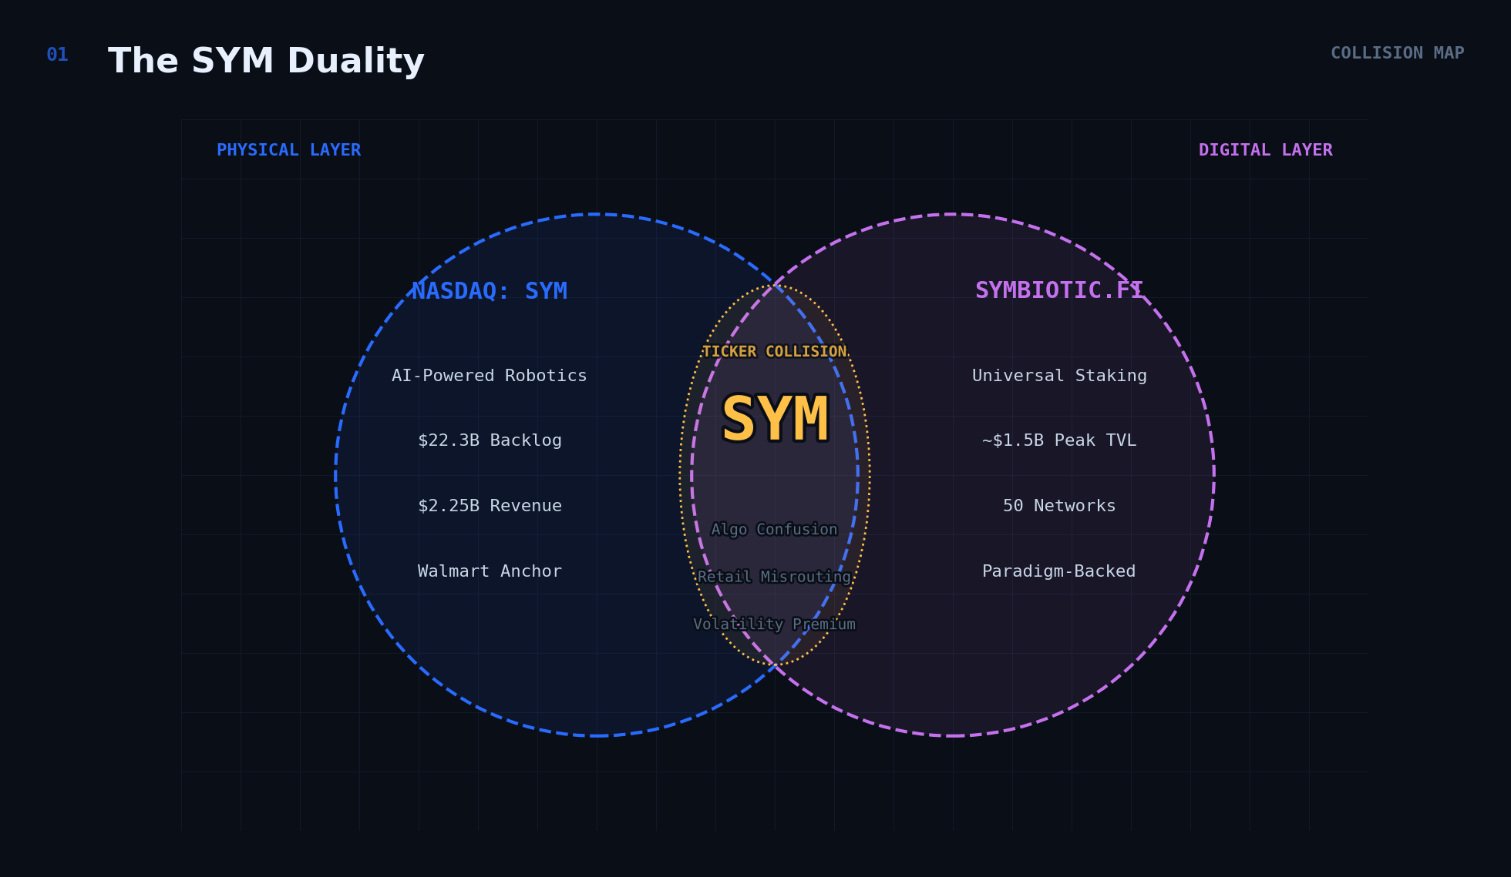
Figure 1: The physical (Symbotic Inc.) and digital (Symbiotic Protocol) domains overlap at the SYM ticker, creating algorithmic confusion, retail misrouting, and an unwarranted volatility premium.

The Bullish Case: Symbotic Inc.
Symbotic delivered Q1 FY2026 revenue of $630 million, up 29% year-on-year, swinging to net income of $13 million from a net loss of $17 million in the prior-year quarter. Adjusted EBITDA surged to $67 million from $18 million, achieving double-digit EBITDA margin for the first time. The company sits atop a $22.3 billion backlog, approximately ten times its annual revenue, anchored by a 12-year strategic partnership with Walmart encompassing up to 400 committed micro-fulfilment centres. Cash and equivalents stand at $1.8 billion following a $424 million follow-on offering. Q2 guidance of $650–$670 million in revenue with $70–$75 million in adjusted EBITDA signals continued acceleration.

The Symbiotic Protocol (Web3 Context)
Symbiotic (symbiotic.fi) is an Ethereum-native universal staking protocol backed by Paradigm and cyber·Fund. It raised $5.8 million in a seed round and $29 million in a Series A led by Pantera Capital with participation from Coinbase Ventures. The protocol reached over $1 billion in TVL faster than any other protocol from initial launch, peaking near $1.5 billion.
Important naming distinction: The crypto protocol is “Symbiotic” (with a ‘b’), while the equity is “Symbotic” (without). Despite the one-letter difference, algorithmic systems frequently conflate the two.

The Ticker Collision Risk
This effect has documented historical precedent. In January 2021, Signal Advance (SIGL) surged over 6,000% after Elon Musk tweeted “Use Signal.” The SEC halted trading in Zoom Technologies (ZOOM) in 2020 due to persistent confusion with Zoom Video (ZM). For the disciplined allocator, the SYM ticker collision creates both risk (unwarranted volatility) and opportunity (mean-reversion entries when crypto-driven spikes reverse).

II. Symbotic Inc. — Equity Analysis

The Walmart Anchor
Symbotic’s relationship with Walmart is the single most important variable in any valuation. The partnership was materially expanded in January 2025 when Symbotic acquired Walmart’s Advanced Systems and Robotics (ASR) business for $200 million in cash, with up to $350 million in contingent consideration. Concurrently, Walmart invested $520 million and signed a Master Automation Agreement covering up to 400 committed and 200 optional micro-fulfilment centres. The 12-year agreement provides exceptional revenue visibility.

Customer Diversification
Target, Albertsons, C&S Wholesale, and Medline (first healthcare vertical customer) are among the names signed to multi-year agreements. The GreenBox joint venture with SoftBank has committed to expend at least $7.5 billion over six years. The Fox Robotics acquisition (Q1 FY2026) brought 25 new potential customers and dock automation capabilities.

Q1 FY2026 Financial Summary
Metric | Q1 FY2026 | Q4 FY2025 | Q1 FY2025 | YoY Change
Total Revenue | $630.0M | $618.5M | $486.7M | +29%
Systems Revenue | $590.3M | $582.3M | $464.1M | +27%
Software & Support | $10.9M | $9.3M | $5.5M | +97%
Operation Services | $28.8M | $26.9M | $17.1M | +68%
Gross Margin | 21.2% | 20.9% | 16.6% | +460bps
Adj. Gross Margin | 23.4% | 22.1% | 17.7% | +570bps
Net Income | $13.4M | ($9.0M) | ($16.9M) | NM
Adjusted EBITDA | $67.0M | $49.4M | $17.9M | +274%
Cash & Equivalents | $1,819M | $1,245M | $903M | +101%

III. Discounted Cash Flow Analysis

Shares Outstanding: ~601 Million (Fully Diluted)
Per the 10-K filed November 24, 2025: Class A: 113,614,046; Class V-1: 74,344,708; Class V-3: 403,559,196—totalling 591.5M. Plus ~10M from the December 2025 follow-on offering = ~601M fully diluted.

Normalised Free Cash Flow Bridge
FY2025 reported FCF of ~$788M is inflated by ~$640M in one-time working capital inflows. Our DCF uses normalised FCFF (~$175M) as the FY2025A baseline to avoid mechanically overstating the decline into FY2026E.

Projected Normalised Free Cash Flow to Firm
Year | Revenue ($B) | EBITDA Margin | Norm. FCFF ($M) | Notes
FY2025A | $2.25 | 6.5% | ~$175 | Normalised (excl. WC)
FY2026E | $2.75 | 10.5% | $165 | Deployment ramp
FY2027E | $3.40 | 14.0% | $305 | Scale leverage
FY2028E | $4.15 | 18.0% | $510 | Margin inflection
FY2029E | $4.85 | 20.0% | $690 | MFC revenue starts
FY2030E | $5.60 | 21.5% | $870 | International
FY2031E | $6.45 | 22.0% | $1,020 | Recurring > 10%

Valuation Output
Component | Value
PV of FCFs (FY2026–FY2031) | $2,580M
PV of Terminal Value (3.0% TGR) | $7,530M
Enterprise Value | $10,110M
Plus: Net Cash | +$1,800M
Equity Value | $11,910M
Shares Outstanding | ~601M
Intrinsic Value / Share (Base) | $20

Exhibit 2: Backlog vs. Market Cap — Value Bridge
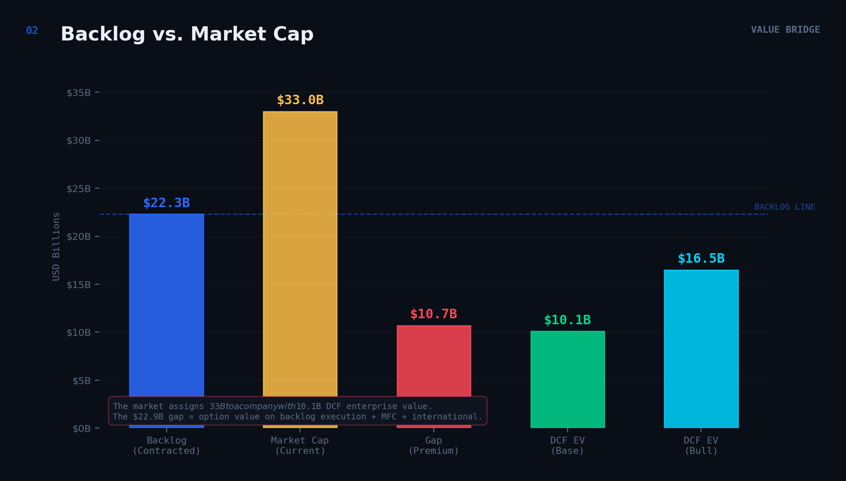
Figure 2: The market assigns $33B to a company with $10.1B in DCF enterprise value. The $22.9B gap represents option value on backlog execution, MFC rollout, and international expansion.

Exhibit 3: DCF Sensitivity Heatmap
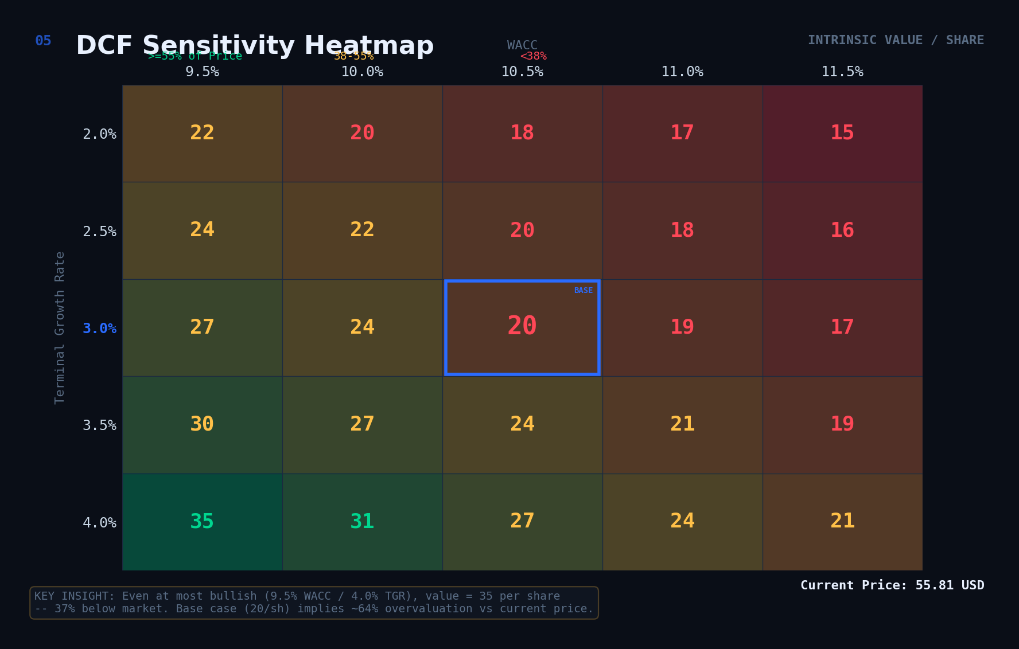
Figure 3: Intrinsic value per share across WACC (9.5%–11.5%) and Terminal Growth Rate (2%–4%) scenarios. Base case highlighted at 10.5% WACC / 3.0% TGR = $20/share. Even the most bullish scenario ($35) implies significant overvaluation vs. market.

EV/Revenue & EV/Backlog Peer Comparables
Given Symbotic’s transitional earnings profile, trailing P/E (~535x) is noise. We use EV/Revenue and EV/Backlog as primary comparables:
Company | EV ($B) | FY Rev ($B) | EV/Rev | Backlog ($B) | EV/Backlog
Symbotic (SYM) | ~$31 | $2.25 | 13.8x | $22.3 | 1.4x
Ocado Group | ~$5 | $3.2 | 1.6x | N/A | N/A
AutoStore | ~$8 | $0.6 | 13.3x | ~$0.3 | 26.7x
GXO Logistics | ~$8 | $10.2 | 0.8x | N/A | N/A
Rockwell Automation | ~$32 | $8.3 | 3.9x | ~$7.5 | 4.3x

Symbotic’s 1.4x EV/Backlog is the most compelling metric: the market pays $1.40 for every dollar of contracted future work. If 50% of the backlog converts at 20%+ gross margins, significant value creation is locked in.

Bull and Bear Case
Scenario | MFC Rollout | FY2028E Revenue | Value/Share
Bull Case | 400 MFCs by FY2030 | $5.0B+ | $30–$35
Base Case | 250 MFCs by FY2030 | $4.15B | $20–$25
Bear Case | 150 MFCs, delays | $3.2B | $12–$16

IV. Risk Assessment

Verdict: Exceptional Business, Priced Beyond Fundamentals
Revenue is growing at 29% on an accelerating trajectory. Gross margins are expanding. The company has achieved GAAP profitability for the first time. However, at ~14x forward revenue and a base-case DCF of ~$20, the market requires sustained near-perfect execution.

Customer Concentration
Walmart represents the overwhelming majority of revenue. The 12-year MAA provides contractual protection, but any strategic shift by Walmart could materially impair the thesis.

Internal Controls & Dilution
Material weaknesses remain under remediation ($2.4M spent in Q1 FY2026). The FY2024 restatement ($30–40M revenue reduction) is a concrete reminder of residual risk. The complex V-1/V-3 conversion mechanics and follow-on offerings create ongoing dilution pressure.

V. Symbiotic Protocol — Ticker Collision & Market Reflexivity

Exhibit 4: VetoSlasher Mechanism
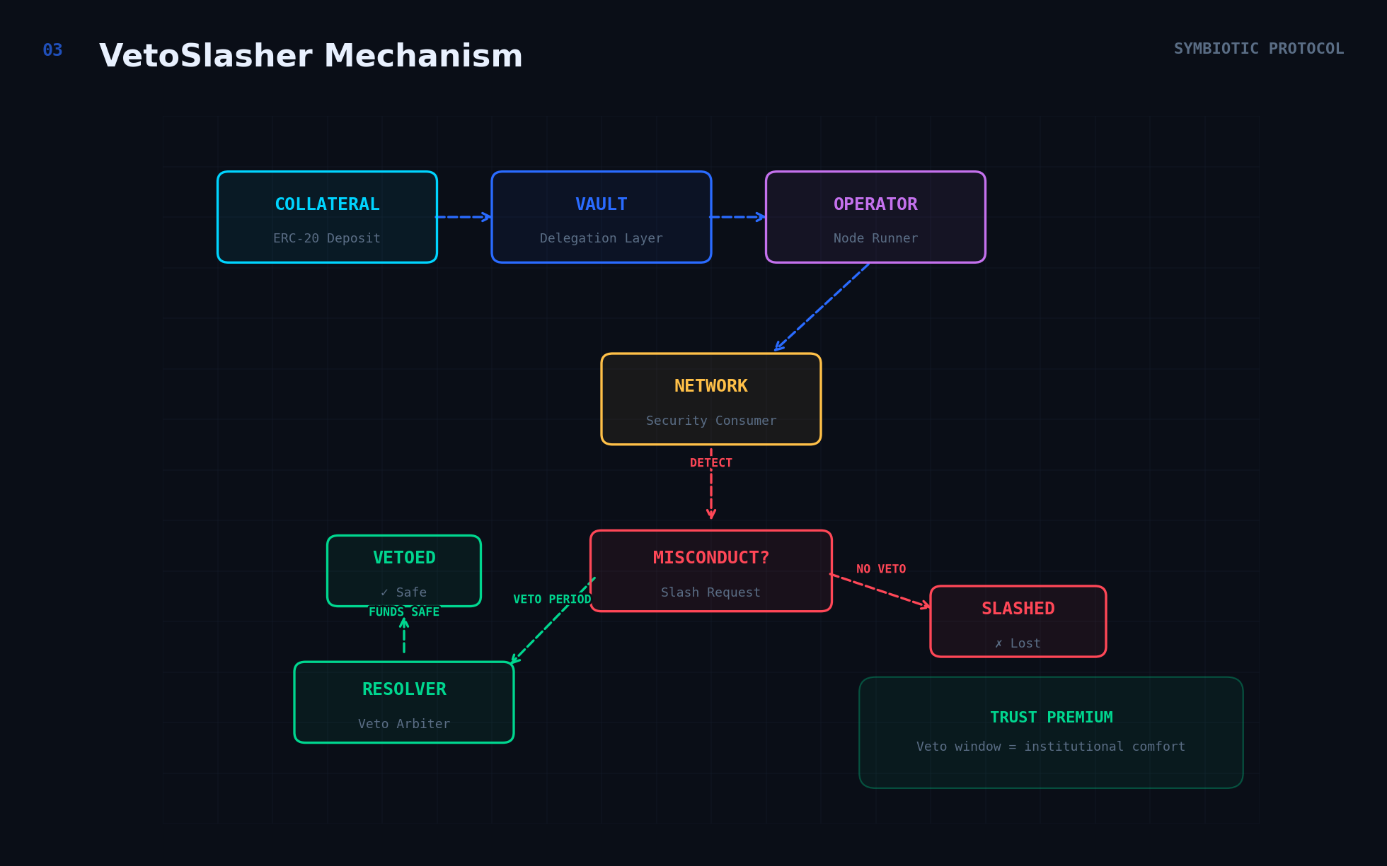
Figure 4: Symbiotic Protocol’s slashing architecture. Collateral flows through Vaults to Operators securing Networks. On misconduct detection, a Resolver can veto the slash during a veto period (Trust Premium), or the collateral is slashed.

Protocol Overview
Symbiotic (symbiotic.fi) raised $5.8M seed (Paradigm, cyber·Fund, June 2024) and $29M Series A (Pantera Capital, Coinbase Ventures, April 2025). Key metrics as of early 2026: ~50 integrated networks, 78 operators, 55 vaults, TVL peak ~$1.5B. The protocol’s asset-agnostic collateral support (any ERC-20, not just ETH) is its key differentiator vs. EigenLayer.

Volatility Spillover: How Crypto Moves the Equity
When Symbiotic protocol news generates crypto media buzz, attention flows into the NASDAQ equity through NLP scrapers that cannot distinguish protocol from equity news, retail investors searching “Symbiotic stock” being directed to SYM, and momentum traders piling into volume spikes regardless of cause.

Exhibit 5: 2026 Catalyst Timeline — Volatility Map
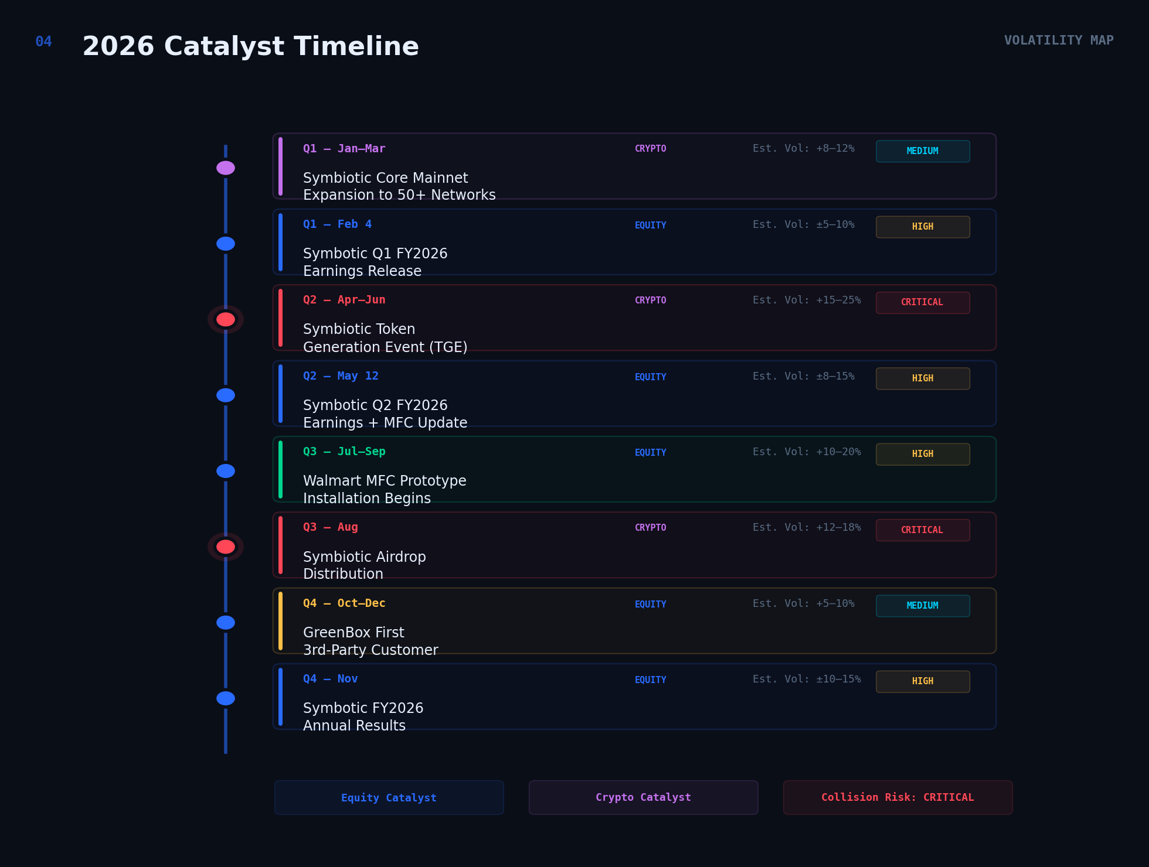
Figure 5: Key 2026 catalysts mapped by origin (Equity vs. Crypto), impact severity, and estimated SYM volatility. The Symbiotic TGE (Q2) and Airdrop (Q3) are flagged as CRITICAL collision risk events.

VI. Summary Verdict & Strategic View

Symbotic Inc. (NASDAQ: SYM)
Verdict: Exceptional business, priced beyond current fundamentals. Watchlist, not pitch.
Symbotic is a genuinely differentiated business at the intersection of robotics, AI, and supply chain infrastructure. The $22.3 billion backlog, 12-year Walmart anchor, and expanding customer base provide a growth runway few companies can match. However, at ~$55 per share and ~14x forward revenue, our normalised DCF suggests a base-case intrinsic value of approximately $20 per share.

Valuation Summary
Metric | Value
Market Cap | ~$33B
Current Price | ~$55
DCF Intrinsic Value (Base) | ~$20
DCF Intrinsic Value (Bull) | $30–$35
EV/Revenue (FY2025A) | 13.8x
EV/Backlog | 1.4x
Optimal Entry Zone | $25–$35

The optimal strategy is patient accumulation on weakness. Maintain a watchlist position. Accumulate on meaningful pullbacks towards $25–$35. Treat any Ticker Collision-driven volatility as a potential entry catalyst rather than a fundamental signal.

“Symbotic is building the physical infrastructure of automated commerce. The Symbiotic protocol is building the digital infrastructure of shared security. The market, for now, occasionally confuses the two. The disciplined investor profits from that confusion.”

Disclaimer: This analysis is for informational purposes only and does not constitute investment advice. All data sourced from SEC filings, company press releases, DefiLlama, and Chainwire. Crypto protocol data as of February 2026.

Source: Symbiotic blog (blog.symbiotic.fi), DefiLlama, Chainwire. Data as of February 2026. Note: The crypto protocol is spelled “Symbiotic” (symbiotic.fi), distinct from Symbotic Inc. (NASDAQ: SYM).
Signal Advance (SIGL) surged ~6,000% in Jan 2021 after Elon Musk tweeted “Use Signal”; Zoom Technologies (ZOOM) was halted by the SEC in 2020 due to confusion with Zoom Video (ZM).
Source: Symbotic 10-K filed 11/24/2025. Class A: 113,614,046; Class V-1: 74,344,708; Class V-3: 403,559,196. Plus ~10M shares from December 2025 follow-on offering.
FY2025 reported FCF of ~$788M includes ~$640M in working capital inflows from deferred revenue acceleration and prepayment timing. Normalised FCF (excluding one-time WC benefit) is estimated at ~$150–$200M.

